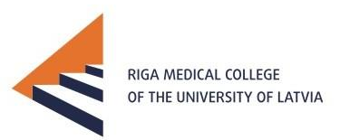 | RIGA MEDICAL COLLEGE  OF THE UNIVERSITY OF LATVIA  1 Hipokrata Str., Riga, LV-1079, Latvia  Phone +371 67840744 Fax +371 67547797 E-mail: koledza@rmkoledza.lv

STUDENT APPLICATION FORM

ACADEMIC YEAR: 2017 /2018
STUDY PROGRAMME:
STUDY YEAR:

HOME UNIVERSITY
Name and full address: Tbilisi State Medical University

Department coordinator (name, telephone, e-mail): Meda Jgharkava
Institutional coordinator (name, telephone, e-mail): Nino Kandelaki

STUDENT’S PERSONAL DATA
First name(s):  Family name(s):  Date of birth:  Gender: | Nationality:  Address:  Tel.:  E-mail:

LANGUAGE COMPETENCES
Mother tongue: Georgian:
Other languages | A1 | A2 | B1 | B2 | C1 | C2
1.English | □  □  □ | □  □  □ | X  X  □ | □  □  □ | □  □  □ | □  □  □
2.Russian
3.

MOBILITY PERIOD
From: | To:
……./February/2018  date/month/year | ..…../April/2018  date/month/year
Please attach Transcript of records and Learning Agreement

SENDING INSTITUTION
We hereby acknowledge the nomination of the mobility applicant.
Student’s signature  ..............................................................................  Date: .................................................................... | Coordinator’s signature  Medea Jgharkava  Date : ............................................................................

RECEIVING INSTITUTION
We hereby acknowledge receipt of the application, the proposed learning agreement and the candidate’s Transcript of records.
Departmental coordinator’s signature  Linda Alondere  Date: .................................................................... | Institutional coordinator’s signature  Astra Bukulite  Date : ............................................................................

